**TECRIDGE SYSTEM DESIGN DOCUMENT**

**Purpose and Scope:**

Students gain practical experience only by indulging themselves into different projects and only through this they get introduced to new concepts of technologies whose practical knowledge can help them in their career. But the students with skills may not be having ideas and people with ideas may not be having skills to work upon those ideas.Majority of the developers today are cut half their way because of lack of motivation in the area of their interest. Today technology has grown far way long, that all fields of developing can combine to produce great products.Scope of this project can be upto a college but is also extensible to other colleges.

**System Architecture:**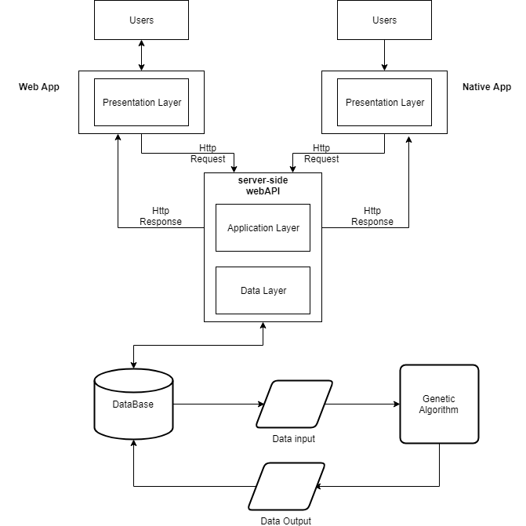

**Design constraints:**

1)Web app:

* design a website that is extremely easy to navigate, looks good at both orientations and gives the barest minimum content mostly in text format. While this sounds simple, there is a lot of thought that needs to go in the UI and content development.
* unlike print designs, where the viewing area of any design is fixed, web users can (and do) zoom in or out as they interact with a web page, changing the size of text and images. And, by the way, different browsing environments handle zoom differently

2)API (RESTful):

* Uniform Interface
* Stateless
* Cacheable
* Client-Server
* Layered System
* Code on Demand

3)Genetic-Algorithm:

* High Computational Power
* Highest fitness value may not be optimal

4)Native Mobile app

## **Small Screen Sizes and Clunky Controls**: Even as screen sizes become larger and larger, the overall mobile experience is still not an optimal method for reading or accomplishing tasks.

## **Environments Full of Distractions:**Mobile users are much more prone to dropping off than their web counterparts. Phones are often used in non-work settings

## **Broken Data Passing:** Data Passing is pretty complex in mobile apps. No contextual data is stored ,therefore nothing is passed from existing apps to a recently installed app.

**Software Modules:**

The following softwares would be utilized in implementing the model:

1) React is

2) Node js

3) Firebase API

4) HTML/CSS

5) React-Native

6) Redux js